**ARUN JEEVARATHNA MABEN**

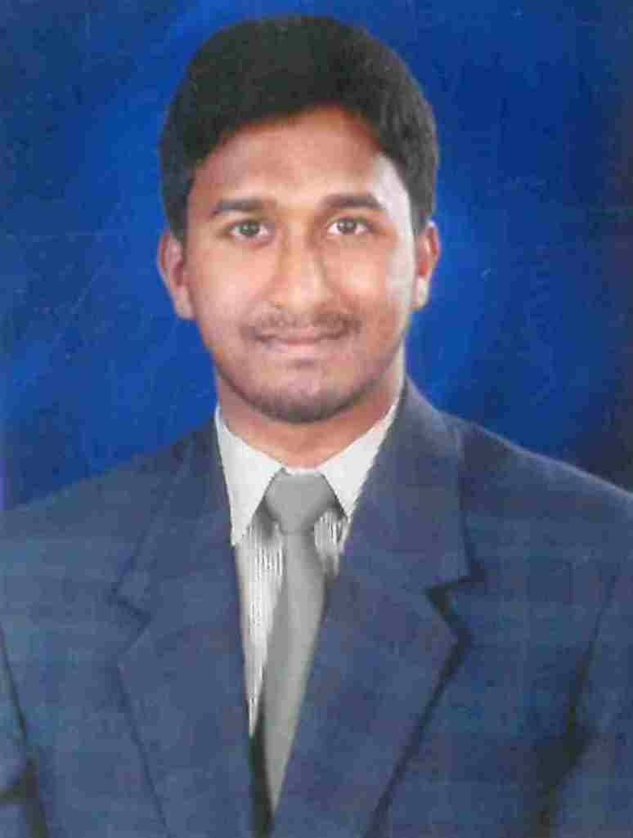

Tel: +9738901290 Email:arunm106@gmail.com

OBJECTIVE

To use present knowledge, capabilities and skills to provide the best possible professional support to my company and my organization which will offer opportunities to learn continuously and to enhance my professional and personal skills.

STRENGTHS &EXPERTISE

* Profession Marketing Executive
* Fixing Seminar for a every College
* Good in ms office & excel spreadsheets and report making.

WORK EXPERIENCE

* Worked as an **SALES EXECUTIVE at Bigbazaar Udupi, K**arnataka - India since 1 year 3 Months.
* Worked as an VETA English Speaking Course since 2 years for marketing executive.
* Working as Time Institute Udupi for 3 years 10 months till date (Marketing Executive)

EQUCATIONAL QUALIFICATIONS

* 20013 BACHELOR OF BUSINESS MANAGEMENT from MANGALORE UNIVERSITY – KARNATAKA
* 2009 XII from DEPARTMENT OF PRE-UNIVERSITY EDUCATION - KARNATAKA
* 2007 X from KARNATAKA SECONDARY EDUCATION EXAMINATION BOARD – KARNATAKA

SKILLS SETS

* Windows Operating System.
* Microsoft (Word, Excel, PowerPoint, )
* Tally, Access, Excel
* And all the basic knowledge in the Computer including Internet.

STRENGTHS

* Good Analysing capacity and to focus on solving challenges.
* Quest for learning.
* Able to work independently as well as a team member/team leader.
* I believe in hard as well as smart working.
* Good communication skill.

PERSONALS DETAILS

NAME : ARUN JEEVARATHNA MABEN

FATHER’S NAME : Prabhakar Maben

DATE OF BIRTH : 12-08-1990

ADDRESS : “Anugraha” house, Korangrapady,

Udupi – 576 101

Karnataka, INDIA

NATIONALITY : Indian

RELIGION : Protestant Christian

STATUS : Single

LANGUAGES KNOWN : English, Hindi (Reasonable) Kannada & Tulu

MOBILE NO. : 9738901290

Email : arunm106@gmail.com

DECLARATION

I would like to assert to the full of my satisfaction that, I would put in my best efforts in the organization I work, for the best possible results.

**PLACE: UDUPI**

**DATE: (ARUN JEEVARATHNA MABEN)**